ONLINE HEALTH INSURRANCE MANAGEMENT

Student name: Student ID:

ALAYBA AHMED KHAN Student 1300303

SALWA ZAFAR Student 1298419

SYEDA KISSA MUBARKA Student 1299659

HOME PAGE



OUR PLAN



ABOUT US PAGE



BLOG



CONTACT US

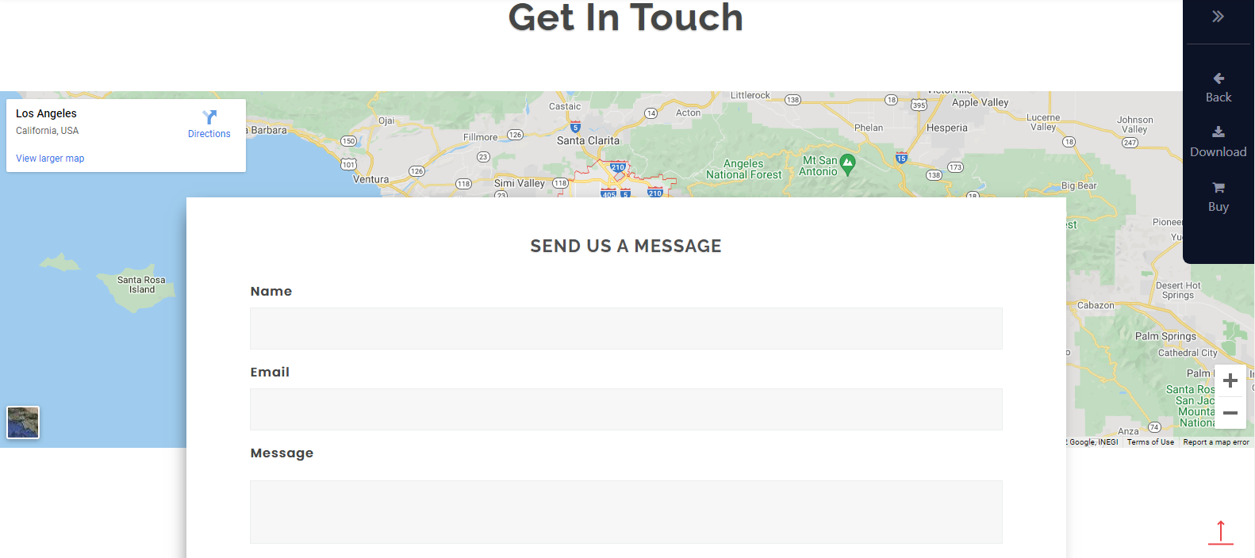

FOOTER

